EECS 495-Database

Project 1

Question 1:

select Movie

from appeared_in

where STAR = 'Edward Norton';



Question 2:

select distinct Star_s.STAR

from appeared_in Star_s, appeared_in Pitt

where Pitt.STAR = 'Brad Pitt'

and Pitt.Movie = Star_s.Movie

and Star_s.STAR != 'Brad Pitt';

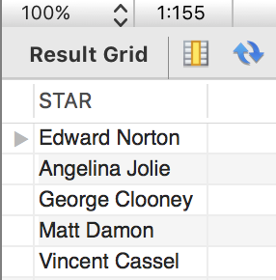

Question 3:

select sum(distinct made_money.HOW_MUCH)

from made_money, appeared_in A_Star, appeared_in B_Star

where A_Star.STAR = 'Tom Hanks'

and B_Star.STAR = 'Rita Wilson'

and A_Star.Movie = B_Star.Movie

and A_Star.Movie = made_money.Movie;

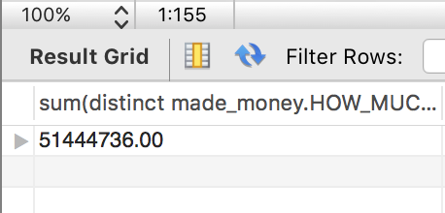

Question 4:

select distinct B.STAR

from divorced, in_couple A, in_couple B

where divorced.COUPLE_NUM = A.COUPLE_NUM

and A.STAR = 'Ben Affleck'

and A.COUPLE_NUM = B.COUPLE_NUM

and A.STAR != B.STAR;

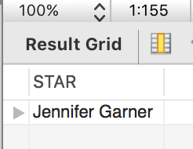

Question 5:

select A.star

from in_couple as A

where A.couple_num in(select d.couple_num

from married as M, divorced as D

where m.day = d.day)

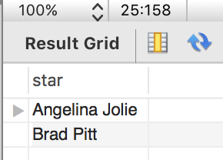

Question 6:

SET sql_mode=(SELECT REPLACE(@@sql_mode,'ONLY_FULL_GROUP_BY',''));

select distinct A.star, B.star

from appeared_in A, appeared_in B, in_couple C, in_couple D, married

where A.movie=B.movie

and A.star<>B.star

and C.star<>D.star

and C.couple_num = D.couple_num

and A.star = C.star

and B.star = D.star

group by C.couple_num

having(select C.couple_num in (select couple_num from married));



Question 7:

select STAR

from (select STAR, count(Movie) as count

from appeared_in

group by STAR order by count desc) A_STEP

where A_STEP.count >= ALL ( select count(Movie) as count

from appeared_in

group by STAR order by count desc);



Question 8:

SET sql_mode=(SELECT REPLACE(@@sql_mode,'ONLY_FULL_GROUP_BY',''));

select A.STAR,B.STAR

from (select *

from in_couple natural join married

group by couple_num)A, in_couple B

where A.couple_num = B.couple_num

and A.STAR<>B.STAR

group by A.STAR

having count(A.STAR)>1

and count(B.STAR)>1;



Question 9:

select STAR

from (in_couple natural join divorced)

group by STAR

having count(STAR)>1



Question 10:

select A.STAR

from (select STAR , avg(HOW_MUCH) as avgmoney

from made_money natural join appeared_in

group by STAR)A

order by A.avgmoney desc

limit 1

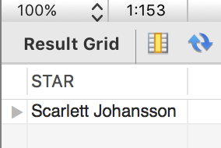

Question 11 (extra credit):

SET sql_mode=(SELECT REPLACE(@@sql_mode,'ONLY_FULL_GROUP_BY',''));

select A_STAR, B_STAR

from

(select A_STAR, B_STAR, couplenum, max(average)

from

(select A_STAR, B_STAR, couplenum, avg(HOW_MUCH) as average

from

(select *

from

(select couplenum, STAR as A_STAR, B_STAR, DAY as finalday, firstday, Movie

from

(select couple_num as couplenum, A_STAR as STAR, B_STAR, firstday, DAY

from

(select A.couple_num as couple_num, A.star as A_STAR, B.star as B_STAR, A.day as firstday

from (select *

from in_couple natural join married

group by couple_num)A, in_couple B

where A.couple_num = B.couple_num

and A.star<>B.star)q natural join divorced)w

natural join appeared_in)e natural join made_money

where day_opened<finalday

and day_opened>firstday

union

select Movie, couplenum, A_STAR, B_STAR, finalday, firstday, HOW_MUCH, day_opened

from

(select couplenum, STAR as B_STAR, A_STAR, DAY as finalday, firstday, Movie

from

(select couple_num as couplenum, A_STAR, B_STAR as STAR, firstday, DAY

from

(select A.couple_num as couple_num, A.star as A_STAR, B.star as B_STAR, A.day as firstday

from (select *

from in_couple natural join married

group by couple_num)A, in_couple B

where A.couple_num = B.couple_num

and A.star<>B.star)q natural join divorced)w

natural join appeared_in)e natural join made_money

where day_opened<finalday

and day_opened>firstday)r

group by couplenum

order by avg(HOW_MUCH) desc)t)y;

